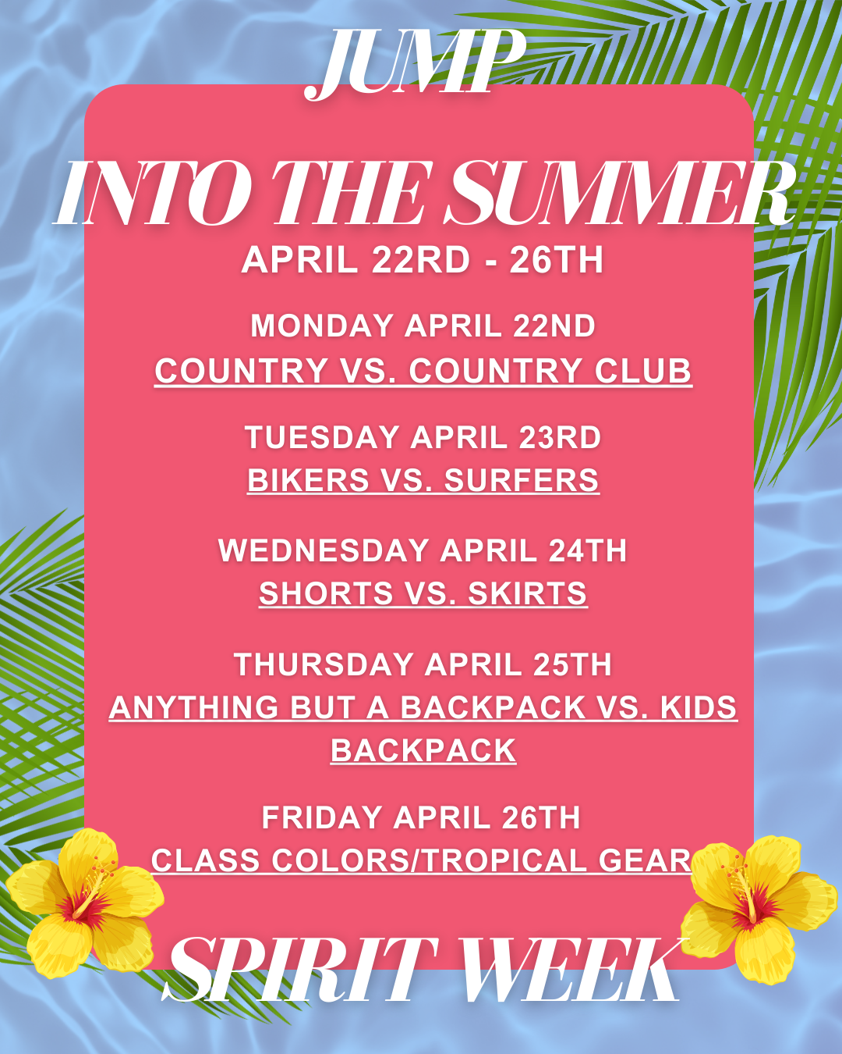
Date: | Events: | Location: | Spirit Days:
Friday, April 19th | Roller Skating Night | Santa Cruz Roller Palladium | Meet in front of school by 4:00 for check in
Monday, April 22nd | Earth Day |  | Country vs Country Club
Tuesday, April 23rd | Tie Dye Shirts  during lunch |  | Bikers vs Surfers
Wednesday, April 24th | Tie Dye Shirts  during lunch |  | Shorts vs Skirts
 | Boys Volleyball SR Night | PVHS GYM | Wear Tropical Gear
Thursday, April 25th | Splash a SR | In the Quad During Lunch | Anything BUT a Backpack vs Kids Backpack
Friday, April 26th | School Rally | In the Gym | Class Colors & Tropical Gear
 | Slim Party  After School | In the Quad

Rally Schedule (A/B-DAY)
Rally will be on Friday, April 26th
Bag Policy:  1. Leave all bags & backpacks in your 6th period class.  a. Those that do not have a 6th period can leave their bags in the main office.  2. Teachers please do not let students out with their bags. If you have a sub that day please make sure they have clear instructions that students are to leave their bags in the classroom. Students will have plenty of time to go back and get them. | Rally Policy:  1. In each rally you are able to cheer with your classmates in the Class Chant Competition.  2. One thing we DO NOT DO at PVHS is boo each other. We cheer each other on!  3. If there is booing we will remind each other of the rules. The second time there is booing we will remove those students.  4. We also make sure to show Grizzly Pride in the rallies and keep our hands and feet to ourselves. If we are unable to do so we will stop the rally and those students will be asked to wait in the main office till the end of the day.
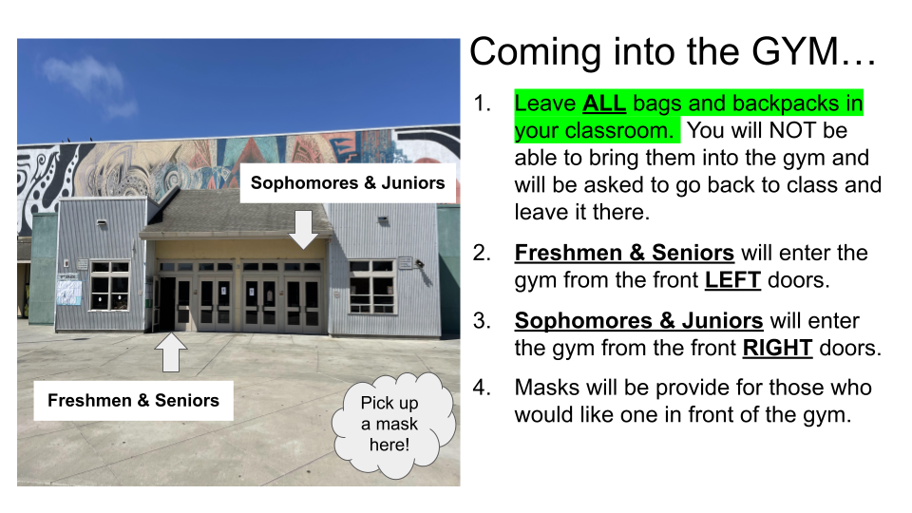  Doors they go into for the GYM | 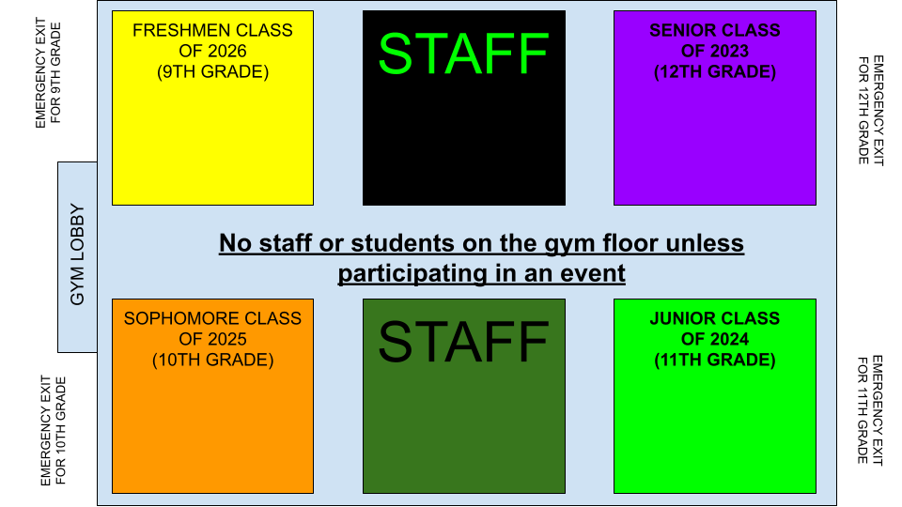  What they sit in the gym

SENIOR PARADE
This is something that we started before COVID and we would like to bring it back!

- Seniors will meet behind the gym and enter AFTER everyone else has come into the gym
- Seniors will parade around the gym and go and sit in their Section
----------
- Towards the end of the Rally Teachers will be asked to make a tunnel from the Senior Section to the gym lobby
- We will then ask the Seniors to leave…Sad Day
- Teachers will open up the tunnel to block the gym lobby doors
- We will then ask the Juniors to take their place as the head of the school
- Once the juniors are in their NEW section the rally will end

I will send a video to everyone on how this should loook.

